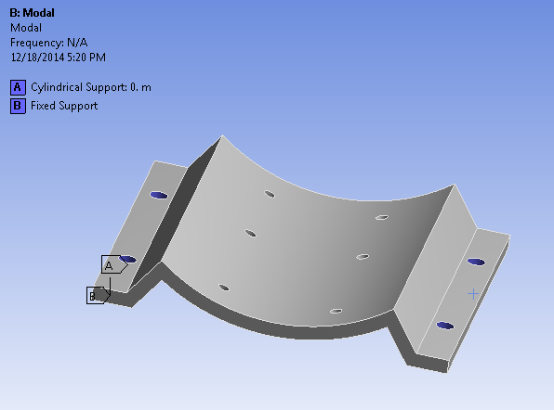

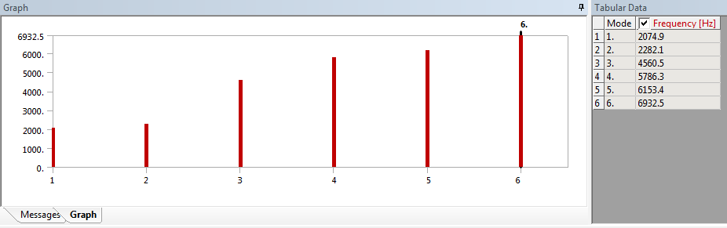

The rpm of the driveline motor is 1750, and the natural frequency of the motor mount is over 2000.

Adapter plates

End plates

Eccentric Change